

**Soft Computing IA2 report**

Submitted

by

**Rohit Sattendra Deshpande**

Roll No: 16010122041

Class- TY COMPS A

**Department of Computer Engineering**

**K. J. Somaiya College of Engineering**

**(Constituent College of Somaiya Vidyavihar University)**

**Table Of Contents**

**Chapter 1: CNN-Based Image Quality Classification Considering Quality Degradation in Bridge Inspection Using an Unmanned Aerial Vehicle………………………………………1**

**Chapter 1:**

**CNN-Based Image Quality Classification Considering Quality Degradation in Bridge Inspection Using an Unmanned Aerial Vehicle**

**Introduction**

The use of Unmanned Aerial Vehicles (UAVs) for bridge inspections has revolutionized structural health monitoring. UAVs provide enhanced accessibility, reduced costs, and improved safety compared to traditional manual inspections. However, consistent image quality remains a significant challenge in ensuring reliable damage detection. Factors like motion blur, underexposure, overexposure, and focus issues—often arising from UAV movement, environmental conditions, and camera settings—can degrade image quality, leading to incorrect structural assessments.

This research proposes an Image Quality Assessment (IQA) method using Convolutional Neural Networks (CNNs) to address image degradation. The study’s goals are twofold:

1. **Establish a methodology** to maintain consistent image quality during UAV-based bridge inspections by optimizing camera settings.
2. **Develop a CNN-based IQA model** capable of evaluating and classifying images affected by multiple distortions, achieving performance comparable to human assessment while providing faster processing times.

This approach contributes to more reliable structural assessments by addressing quality issues and automating the evaluation process.

**Proposed Methodology for Image Quality Assessment (IQA) using CNN**

This section outlines the overall process developed for consistent image acquisition quality and CNN-based IQA in UAV-based bridge inspections. The methodology is divided into two key stages: (1) image acquisition with appropriate quality settings, and (2) CNN-based classification for image quality assessment.

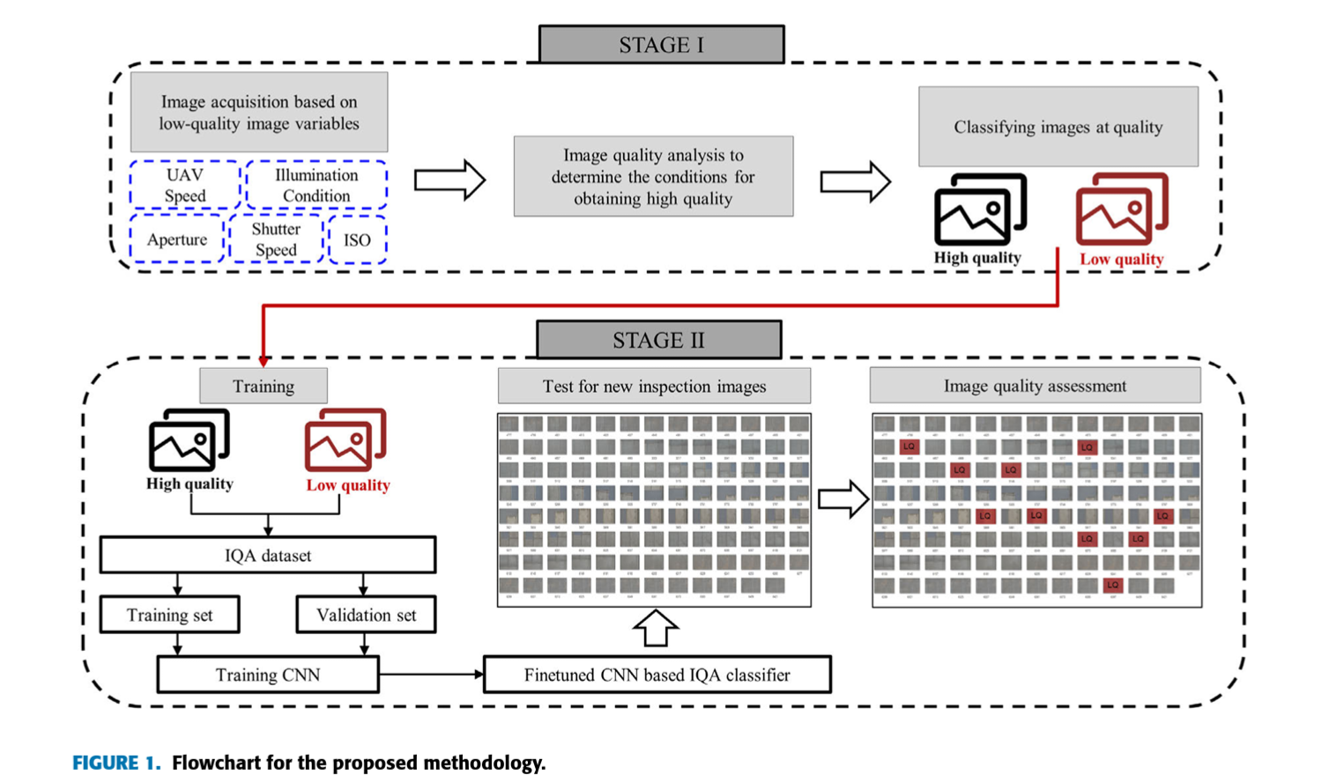

#### Stage 1: Image Acquisition with Quality Considerations

In the first stage, UAVs are used to capture structural inspection images with settings adjusted to minimize degradation such as motion blur, underexposure, overexposure, and out-of-focus issues. Key parameters for image quality include:

* **External Factors**: UAV speed, environmental illumination
* **Internal Camera Factors**: Aperture, shutter speed, and ISO settings

The goal is to avoid common quality issues like motion blur (caused by UAV movement and shutter speed), underexposure (due to low light environments), overexposure (due to excessive light), and out-of-focus images (caused by incorrect focus settings). The inspection image quality is adjusted by controlling these factors, ensuring that high-quality images are consistently acquired.

For instance:

* **Motion Blur Avoidance**: Adjusting UAV speed and shutter speed helps to reduce motion blur.
* **Out-of-Focus Avoidance**: Controlling aperture size helps achieve proper depth of field and focus.
* **Exposure Adjustments**: Using appropriate shutter speed, aperture, and ISO settings ensures proper exposure levels in varied lighting conditions.

The data collected from this stage, consisting of images with different quality levels, is then classified as either high or low quality. This dataset is used for training the CNN-based IQA model in the next stage.

#### Stage 2: CNN-Based Image Quality Classification

In the second stage, a CNN-based model is trained using the dataset prepared in the first stage. The model classifies the images into two categories: high-quality and low-quality. The training process uses 90% of the labeled dataset, while the remaining 10% is reserved for validation.

* **High-Quality Images**: Sharpened images with clear boundaries
* **Low-Quality Images**: Images with motion blur, underexposure, overexposure, or out-of-focus issues

The trained CNN model can then be applied to new inspection datasets to classify image quality automatically. This ensures that low-quality images can be identified and isolated, improving the accuracy and efficiency of structural inspections.



**Hardware and Software Used**

**Hardware:**

* **UAV System**: DJI Inspire 2 UAV used for image capture.
* **Camera**: Zenmuse X7 camera with a 35mm fixed lens.
* **UAV Speed**: Flight speeds ranged from 1 m/s to 4 m/s, affecting motion blur.
* **Camera Settings**:
  + **Shutter Speed**: Varied from 1/100s to 1/8000s to prevent motion blur.
  + **Aperture**: Set between F/5.6 and F/8 to avoid focus issues.
  + **ISO Settings**: Adjusted to handle exposure problems in different lighting.

**Software:**

* **Convolutional Neural Network (CNN)**: Built using VGG-16 architecture.
* **Training Data**: Dataset of 11,990 images (sharp, motion blur, underexposed, overexposed).
* **Transfer Learning**: VGG-16 pre-trained on ImageNet for feature extraction, with fine-tuning for quality classification.
* **Training and Validation**: Model training and validation peaked in performance at the 10th epoch.

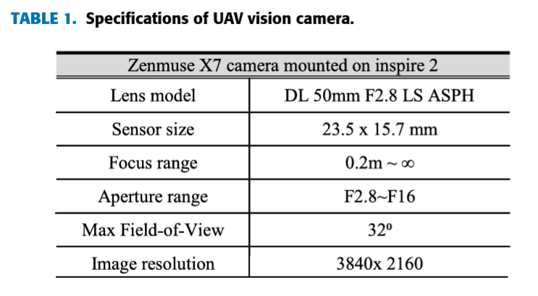

**Experimental Analysis and Validation**

In this section, the proposed CNN-based Image Quality Assessment (IQA) method was experimentally validated using datasets acquired by UAVs during bridge inspections. These validation datasets were not used during model training, ensuring a reliable evaluation of the CNN-based classifier’s performance.

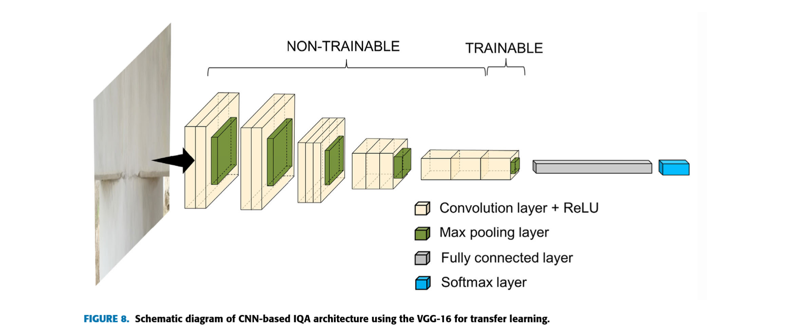

Two experimental validation cases were conducted:

1. **Case 1**: Validation using images with exposure issues.
2. **Case 2**: Validation using images with motion blur degradation.

The performance of the CNN-based IQA model was compared against human visual inspections using the **Mean Opinion Score (MOS)** method, as well as a traditional No-Reference IQA (NR-IQA) approach for blind image quality evaluation. This ensured a comprehensive evaluation from both subjective and algorithmic perspectives.



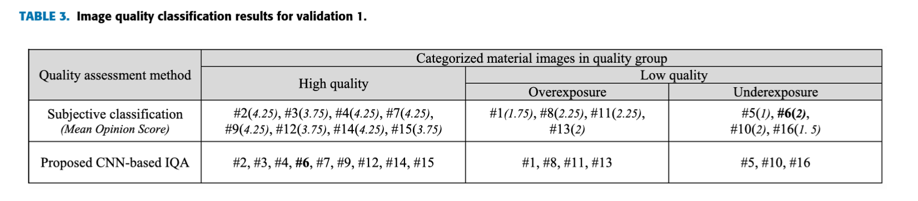

**A. Case 1: Inspection Images with Exposure Issues**

The first validation focused on exposure issues in images from UAV inspections of the E and H bridges. The dataset included images with varying exposure levels, from underexposed to overexposed. Some images, such as #14, displayed visible damage, while others, like #5, were too poorly exposed to detect damage. The CNN-based IQA model was tested against subjective evaluations using the Mean Opinion Score (MOS) method.

The MOS evaluation involved 10 experts rating images on a scale of 1 (bad) to 5 (excellent). The CNN-based classifier results aligned closely with human judgment, as shown in **Table 3**, with only minor discrepancies, such as in image #6, where the CNN model rated it higher despite exposure issues. A **confusion matrix** (Figure 11) and performance metrics (Table 4) further confirmed the accuracy of the CNN model.

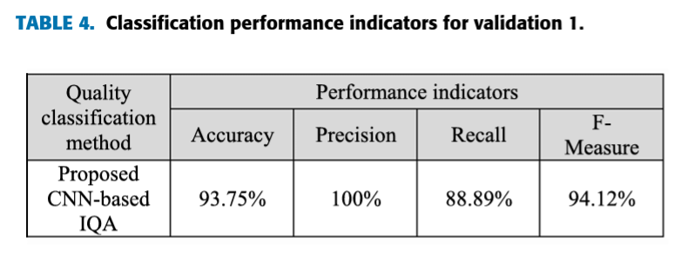

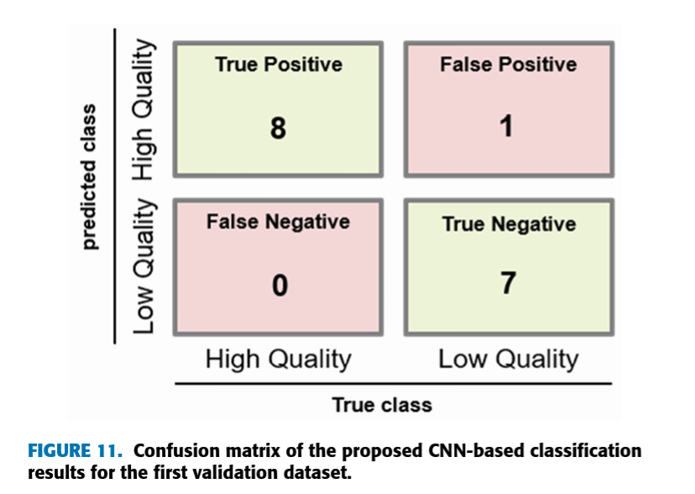

When compared to the traditional **Perception-Based Image Quality Evaluator (PIQUE)** method, the CNN model showed superior classification accuracy, particularly in mid-score ranges, where PIQUE struggled to generalize (Figure 12).

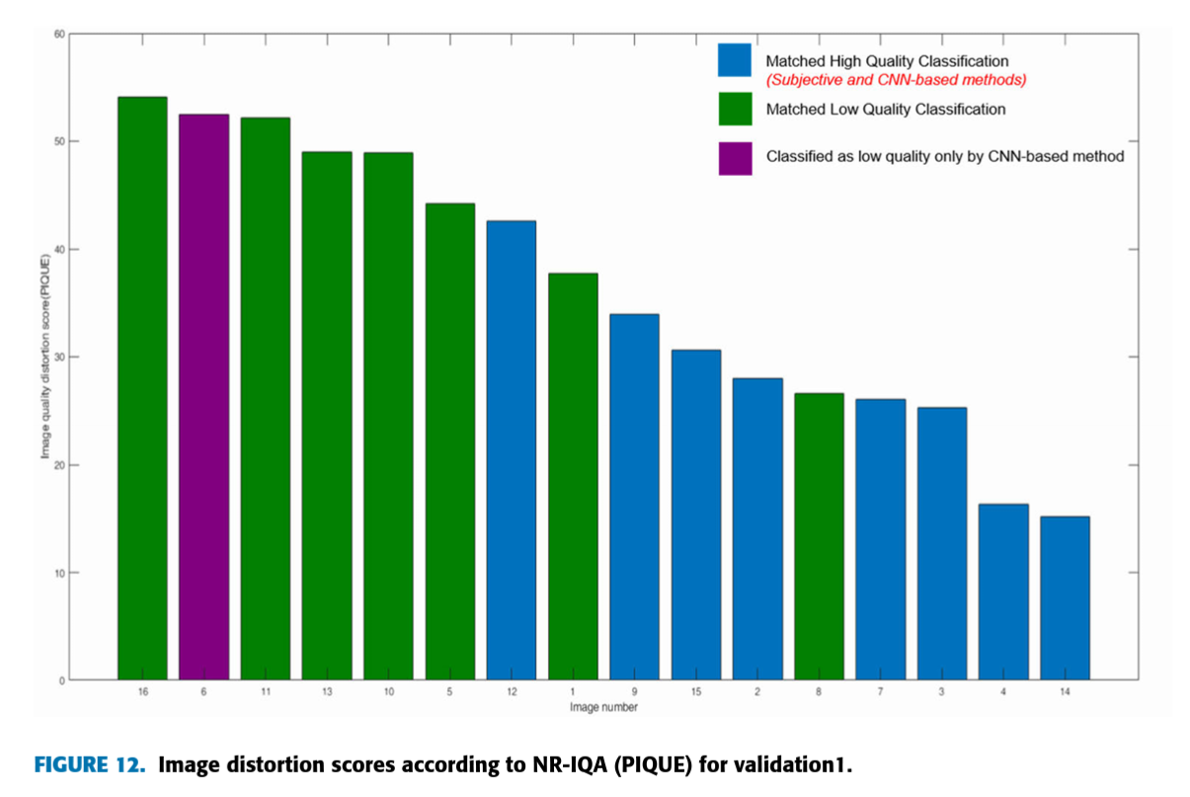

**B. Case 2: Inspection Images with Motion Blur Issues**

For the second validation, new data was collected from a bridge in Chungcheongbuk-do, focusing on motion blur. The dataset included 36 images, some with noticeable blur and others sharp. These images were evaluated using both the CNN model and MOS-based assessments.

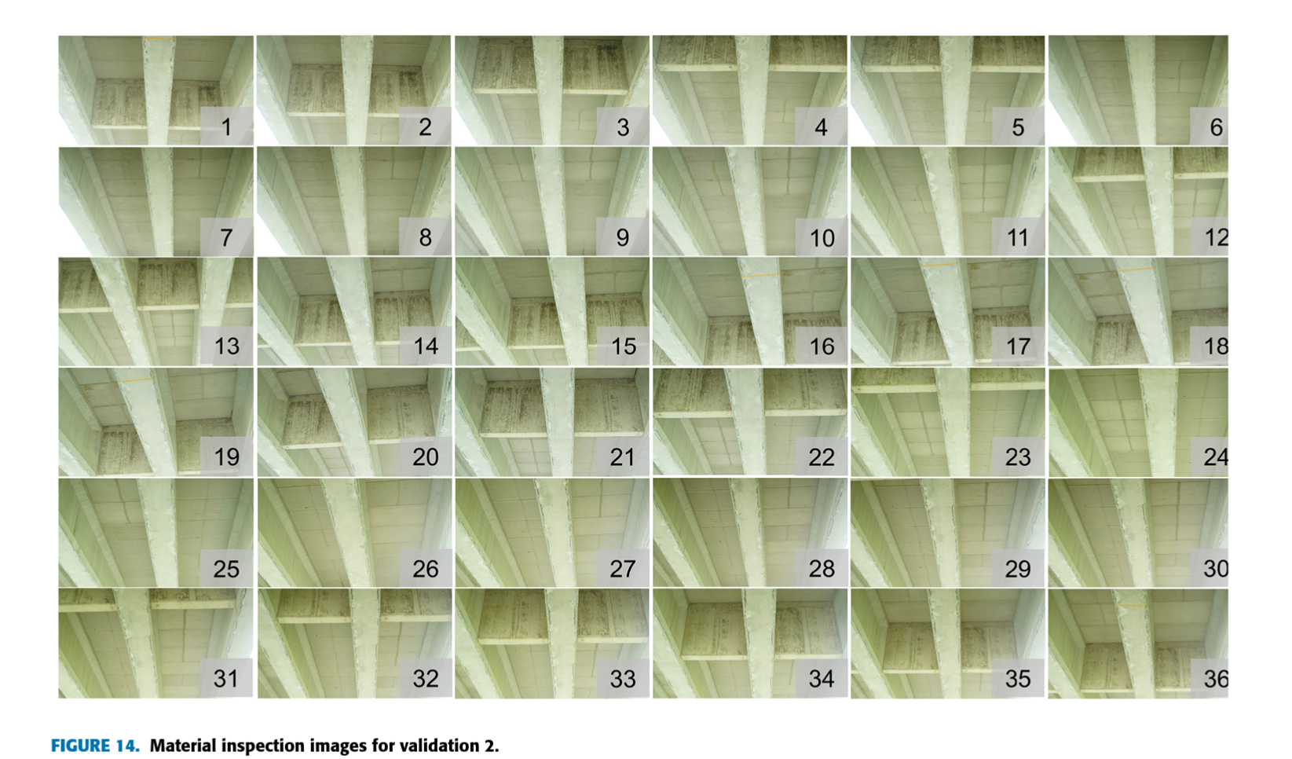

The CNN model effectively classified motion-blurred images, with mostly consistent results compared to the MOS evaluations (Table 5), except for minor disagreements (e.g., image #22). A **confusion matrix** (Figure 17) and performance metrics (Table 6) showed that the CNN model performed well in identifying blurred images. Additionally, when compared with the **Sharpness Gradient Variance (SGV)** method, the CNN model outperformed SGV, especially in cases of mild motion blur (Figure 18).

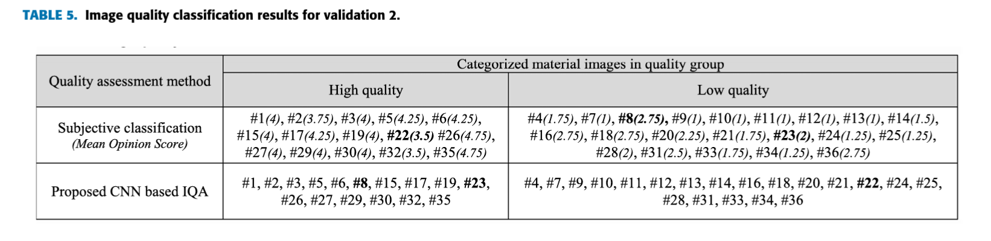

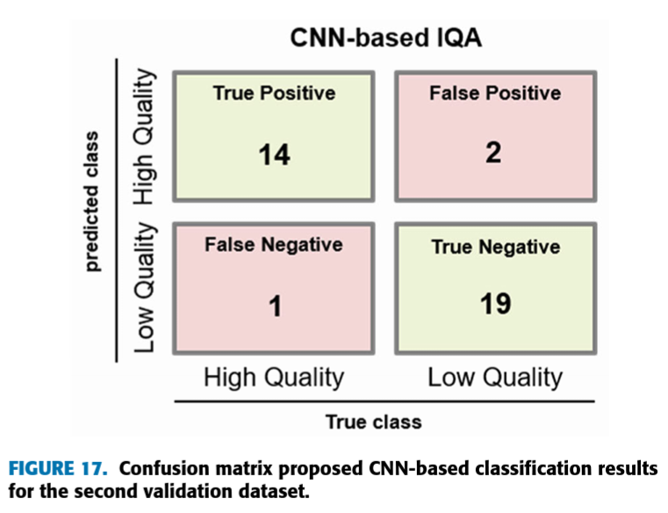

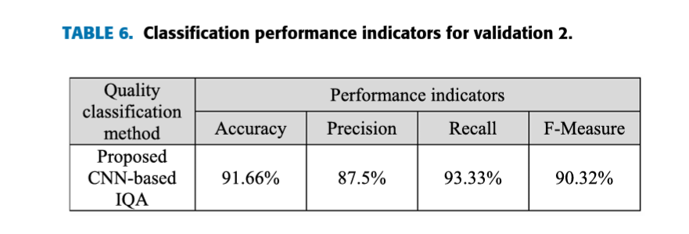

Overall, the CNN-based IQA model demonstrated strong performance across both exposure and motion blur issues. It provided more consistent results than traditional NR-IQA methods, particularly for mid-range distortions. Despite processing challenges—taking 16 hours to analyze large datasets—the method offers clear advantages for bridge inspection, improving 3D modeling and structural evaluations by prioritizing high-quality images.

**Conclusion**

This paper introduced a CNN-based IQA method for classifying images acquired during UAV-based bridge inspections. The proposed framework, consisting of image acquisition adjustments and CNN-based classification, effectively addressed quality degradation issues, including motion blur, exposure, and focus problems.

The CNN model, built using VGG-16 with fine-tuning, demonstrated strong performance in classifying image quality, closely aligning with human visual assessments through the MOS method. It also outperformed traditional NR-IQA methods like PIQUE and SGV in handling complex quality issues, particularly in mid-range distortion levels.

Key benefits of the CNN-based IQA model include faster image processing and improved results for downstream tasks such as 3D modeling and stitching by isolating low-quality images. However, further research is needed to refine the methodology, particularly in evaluating the **severity** of image degradation and developing enhancement techniques to recover low-quality images. Addressing additional challenges, such as shadows and physical obstructions, could further improve the utility of the CNN-based IQA model in practical applications.

**Chapter 2:**

**Fuzzy Logic and Decision Making Applied to Customer Service Optimization**

**Introduction**

The continuous advancement of digital transformation has made customer service a fundamental pillar for companies, with most organizations having access to comprehensive customer data including purchase history, interaction records, and satisfaction metrics. While traditional models like RFM (Recency, Frequency, Monetary) and Customer Lifetime Value (CLV) help evaluate customer worth, modern customer service requires a more sophisticated approach that considers multiple factors beyond just transactional data. This research introduces an enhanced methodology that combines the existing RFID model (Recency, Frequency, Importance, Duration) with additional factors such as Impact, Urgency, and Emotional character of interactions (VIUE). Furthermore, by incorporating Waiting Time and Contact Center Workload considerations, this study presents a dynamic, real-time prioritization system for customer interactions. The proposed approach utilizes fuzzy logic and the Analytic Hierarchy Process (AHP) to unify heterogeneous information through 2-tuple linguistic evaluations, ultimately enabling more effective customer service optimization.

**Customer Service Analysis and Optimization: Literature Review**

The existing research in customer service optimization can be categorized into three main streams:

## Customer Satisfaction Measurement: The foundation of service quality measurement rests on five key dimensions: reliability, assurance, tangibility, empathy, and responsiveness. Traditional metrics such as Net Promoter Score (NPS) and Customer Effort Score (CES) have been widely adopted, though recent research suggests that single metrics are insufficient for comprehensive customer behavior prediction. Instead, a 360-degree approach incorporating multiple metrics provides more reliable insights into customer behavior patterns.

## Customer Segmentation and RFM Analysis: While various data mining techniques (k-means clustering, logistic regression, neural networks) have been employed for customer segmentation, RFM (Recency, Frequency, Monetary) models remain prevalent due to their interpretability and actionable insights. However, there is a notable gap in research specifically addressing customer ratings from a Contact Center perspective.

## Fuzzy Logic in Contact Center Operations: Research applying fuzzy logic to Contact Center operations is notably limited, with only two significant studies identified:

* A 2006 study developing a fuzzy expert system for customer and agent categorization
* A 2009 study on fuzzy rule-based classification systems for customer service data

The literature reveals a significant research gap in dynamic prioritization of customer interactions, with most existing studies focusing on basic routing and queue management. This gap underscores the novelty of the proposed VIUE model, which integrates RFID metrics, ITIL methodology, sentiment analysis, and SLA parameters for comprehensive interaction prioritization.

A bibliometric analysis of publications related to Contact Center priority management shows limited research activity, with only nine relevant publications between 2017-2023, indicating an understudied area in customer service optimization.

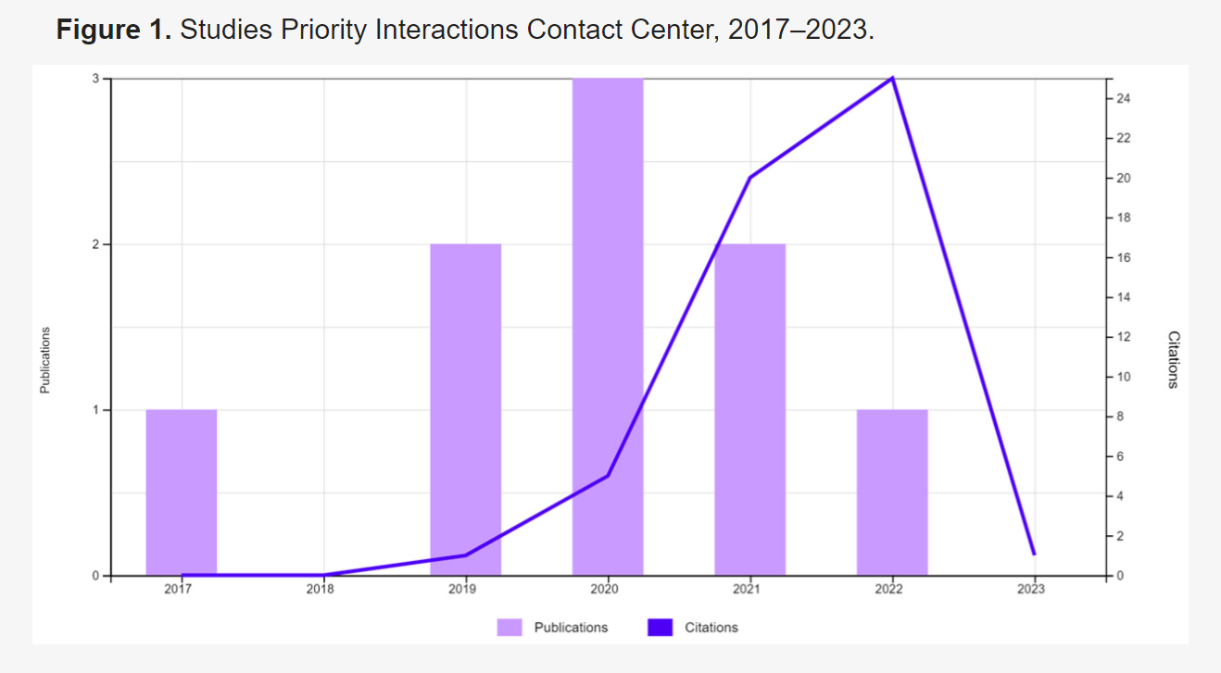

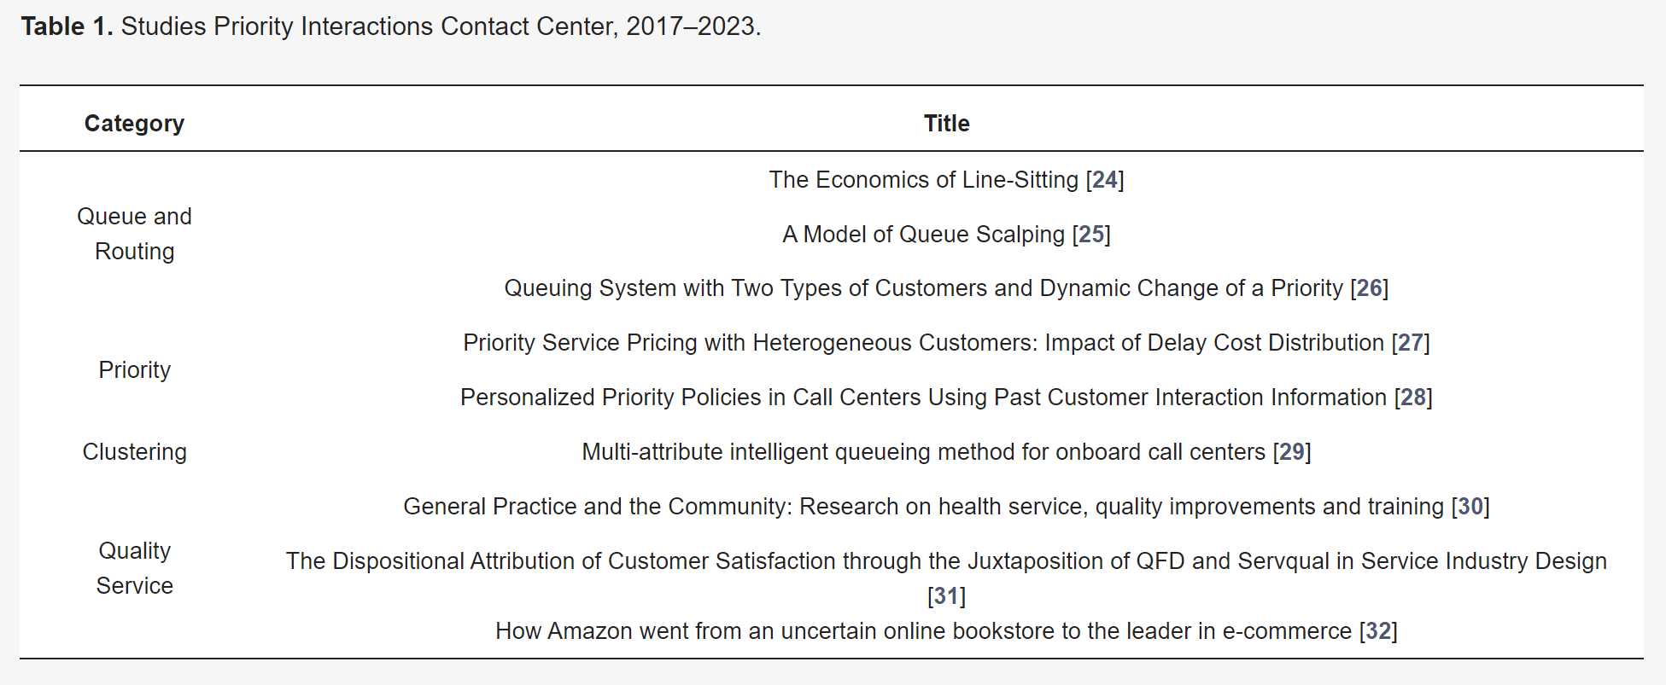

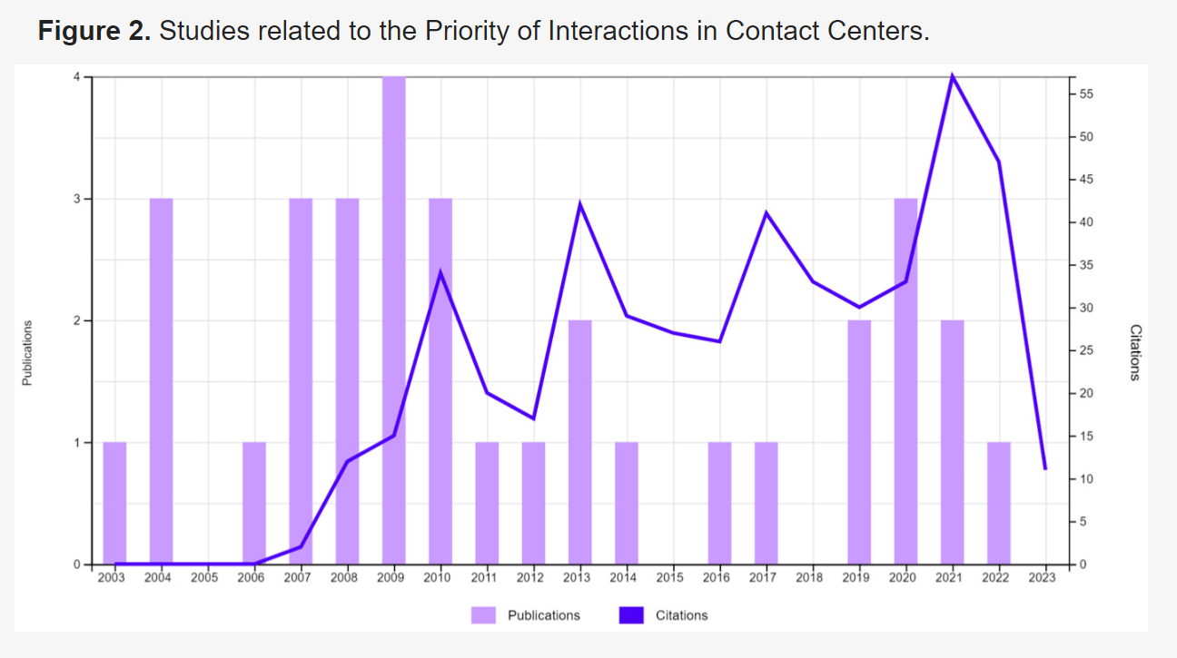

**Hardware and Software Used**

* **Hardware Requirements**: High-performance servers are required to ensure fast processing speeds, given the need for real-time customer interaction management. The system must also support parallel computing to handle multiple interactions simultaneously.
* **Software Requirements**: The software infrastructure involves a Customer Relationship Management (CRM) system, such as Salesforce, integrated with a Contact Center tool for real-time data collection and interaction tracking. Advanced data analytics tools, such as fuzzy logic systems and AHP software, are utilized to manage linguistic term transformations and pairwise comparison matrices.

The computational framework uses **triangular membership functions** for linguistic domain representation, and the **TNS, TIS, and TSS functions** to transform numerical, interval, and linguistic data into appropriate fuzzy representations. These transformations are key to unifying the different types of information within the system. The system must also have intuitive user interfaces to facilitate easy data input and the visualization of results, allowing decision-makers to efficiently interact with complex data.

**Methodology**The study integrated three primary theoretical frameworks: the **2-tuple linguistic model (LD2T)**, the **Analytic Hierarchy Process (AHP)**, and **Heterogeneous information treatment**. This integration addressed the challenges of decision-making in customer service optimization, particularly when handling imprecise or subjective information that defied traditional numerical quantification.

## The 2-Tuple Linguistic Model (LD2T)

The methodology was grounded in the 2-tuple linguistic model, originally proposed by F. Herrera and L. Martinez. This approach effectively addressed a critical challenge in linguistic computing: information loss during processing. The model functioned through paired values (sᵢ, αᵢ), where sᵢ belonged to the linguistic term set S and αᵢ represented a symbolic translation within the interval [-0.5, 0.5). As shown in Figure 3, triangular membership functions were employed to represent the linguistic domain S₅.

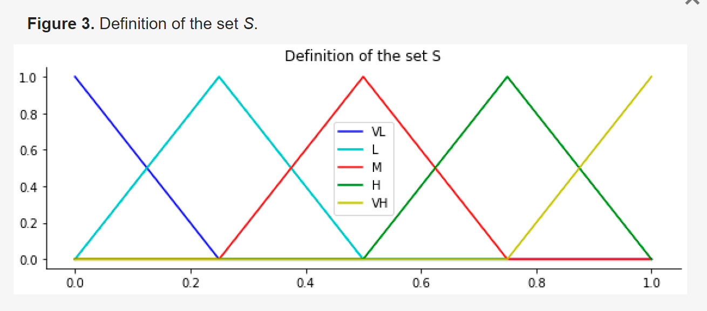

The computational framework incorporated several essential operators. The transformation function ΔS converted numerical values into equivalent linguistic 2-tuples, while its inverse function Δ⁻¹S translated linguistic 2-tuples back into numerical values. The key transformation equations were:



## Analytic Hierarchy Process (AHP)

The AHP methodology, integral to the research framework, provided a structured approach to complex decision-making scenarios. As visualized in Figure 4, the decision-making environment considers multiple factors, including the number of criteria, the decision environment, and the number of experts involved. The process began with the construction of a hierarchical structure (shown in Figure 5), where the primary objective occupies the top level, followed by criteria and sub-criteria in intermediate levels, and alternatives at the bottom.

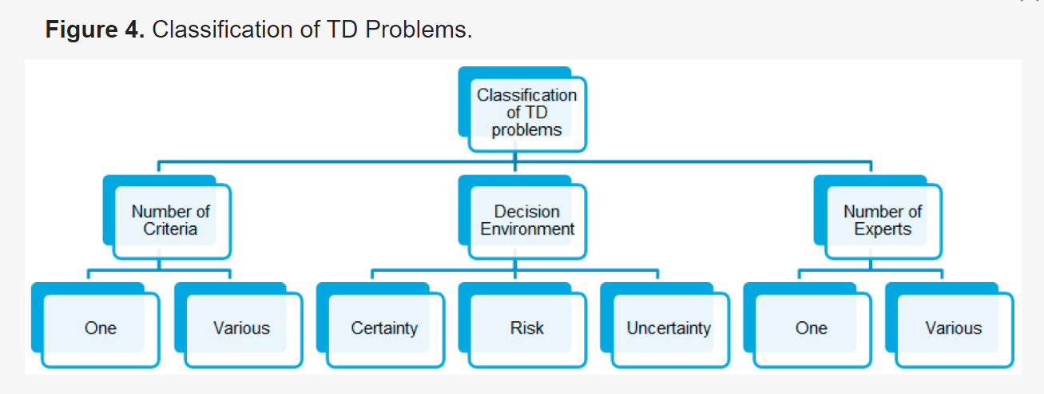

The core of AHP implementation involved pairwise comparisons using Saaty's scale (detailed in Table 3).

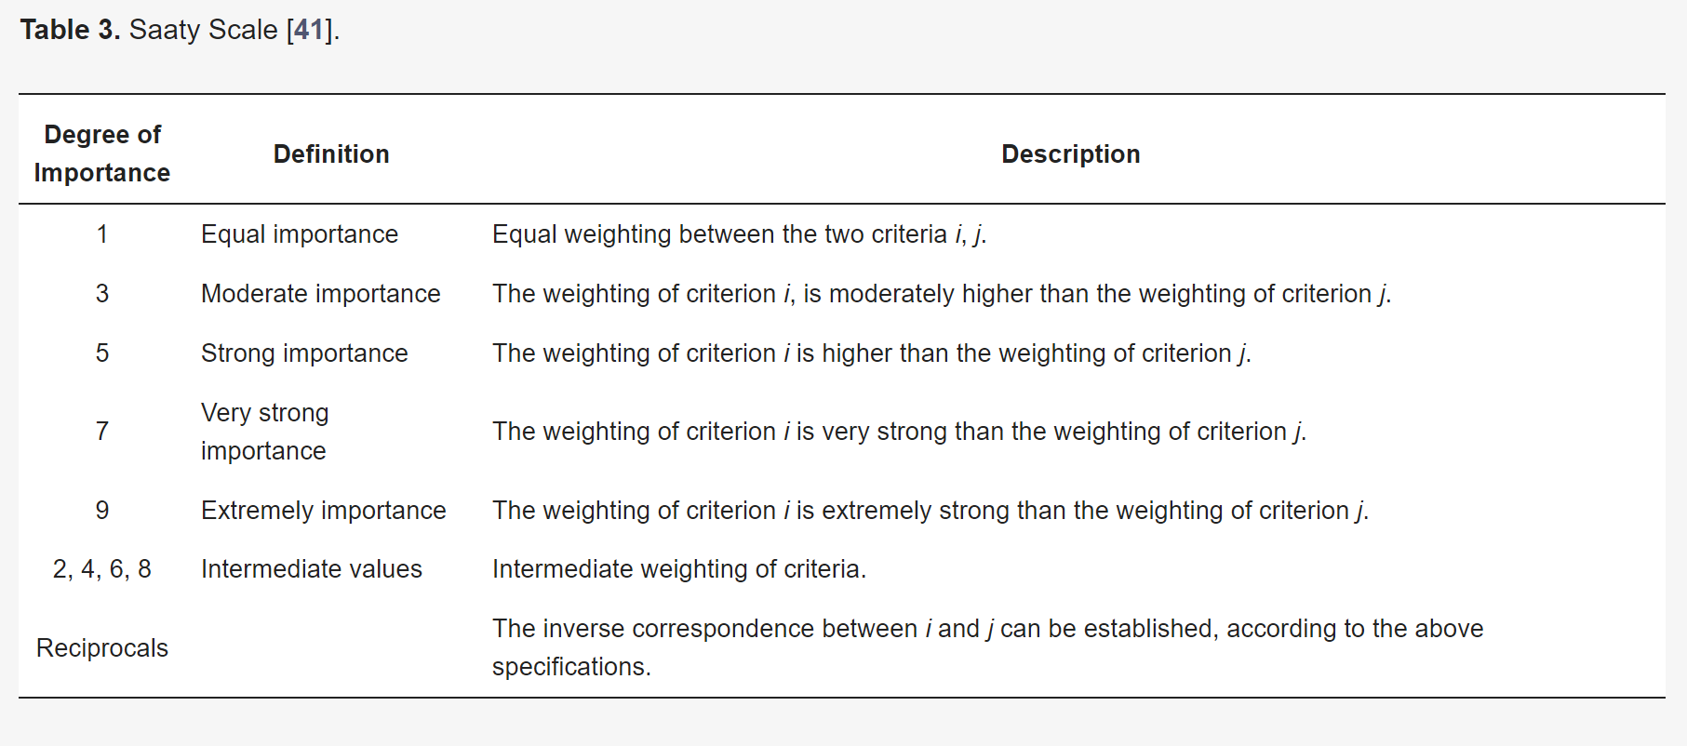

These comparisons generate matrices that undergo rigorous consistency checks through the Consistency Ratio (CR) calculation.



The process ensured reliable decision-making by comparing the Consistency Index (CI) with Random Consistency values (presented in Table 4), subject to the limits specified in Table 5.

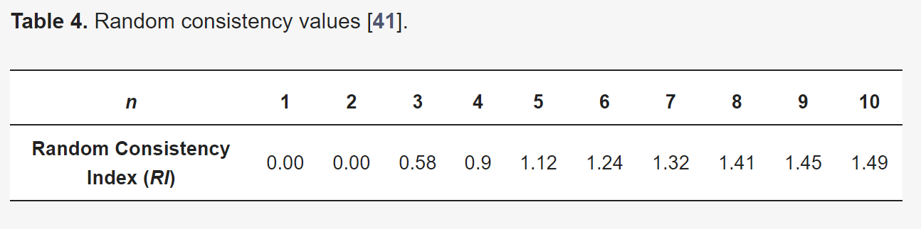

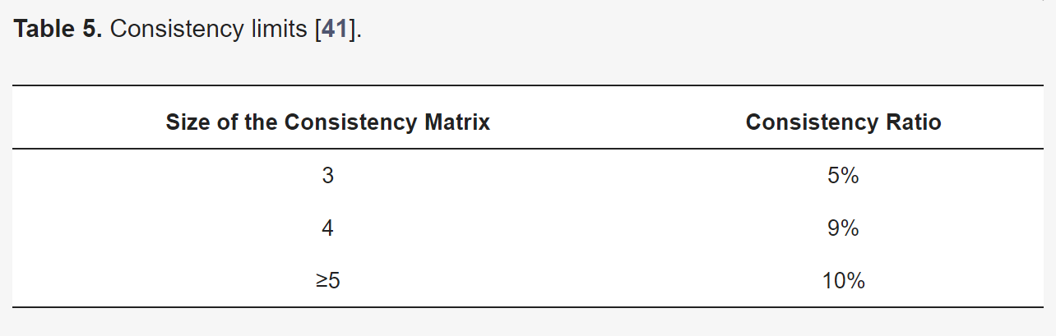

## Heterogeneous Information Treatment

This methodology addressed the challenge of unifying diverse information types through a sophisticated transformation process. The approach begins with selecting a Basic Set of Linguistic Terms (CBTL) that maintains maximum granularity within the heterogeneous framework. As illustrated in Figure 6, the unification process accommodates three distinct domains:

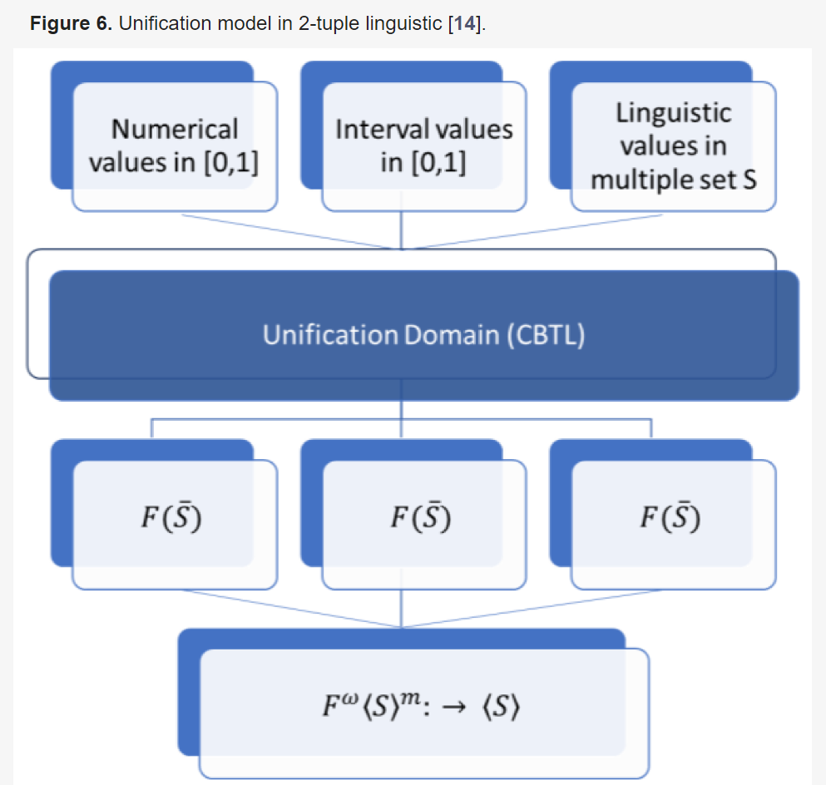

The **numerical domain** transformation employs the **TNS function**, converting precise numbers into fuzzy linguistic representations. Numerical domain transformation through the TNS function:



The **interval domain** uses the **TIS function** to transform ranges of values into appropriate linguistic terms. Interval domain processing via the TIS function:

  
Finally, the **linguistic domain** transformation, facilitated by the **TSS function**, enables the conversion between different linguistic term sets while preserving semantic meaning. Linguistic transformations using the TSS function:  


## Implementation Framework

The practical implementation of this methodology required a robust computational infrastructure capable of handling complex mathematical operations in real-time. The system architecture supports both the mathematical processing requirements and user interaction needs.

### Technical Infrastructure: The implementation framework necessitates a sophisticated software system capable of processing linguistic computations, matrix operations, and fuzzy logic calculations. This system must handle real-time transformations between different information domains while maintaining computational accuracy and efficiency. The infrastructure must support parallel processing of multiple decision criteria and enable dynamic updates to the decision-making model.

### User Interface Considerations: The implementation incorporated intuitive interfaces for both data input and result visualization. These interfaces facilitate easy input of pairwise comparisons and criteria weights while providing clear, interpretable outputs of the linguistic computations and hierarchical analysis results. The system presents complex mathematical results in a format that decision-makers can readily understand and apply.

### Data Processing and Management: The methodology required careful handling of data transformations between different domains. The system maintains accuracy during these transformations while ensuring that the semantic meaning of the information remains intact. This involves sophisticated data structures capable of representing and processing linguistic terms, numerical values, and interval data simultaneously.

Through this comprehensive methodological framework, they established a robust foundation for addressing complex decision-making challenges in customer service optimization, particularly in environments where information precision varies and subjective assessments play a crucial role.

**VIUE Model**

The VIUE model is a sophisticated framework designed to enhance contact center operations by prioritizing and personalizing customer interactions. This approach aims to elevate customer satisfaction while minimizing costs and gathering valuable insights for improved decision-making.

**Key Components**

1. **Interaction Classification:** Interactions are meticulously analyzed and categorized based on key factors such as value, impact, urgency, and emotional nature.
2. **Priority Determination:** A composite score, ℙ, is calculated to prioritize interactions effectively, considering the interplay of these factors.
3. **Contextual VIUE:** A dynamic classification mechanism takes into account SLAs and contact center workload to ensure timely and appropriate responses.
4. **Parameter Determination:** Expert input is crucial in guiding the model's parameters, allowing for real-time adjustments to align with evolving business needs.
5. **Process Flow:** The VIUE model follows a structured process:
   * Data collection from CRM systems
   * Definition and computation of CBTL domains
   * Calculation of overall VIUE scores
   * Reordering of interactions based on contextual VIUE
   * Recommendations for personalized responses

**VIUE Model in B2B Software Licensing**

The **VIUE model** is applied in the context of a Business-to-Business (B2B) software licensing manufacturer, where a CRM (Salesforce) manages ticket information, tracking real-time interactions between partners and the manufacturer. These interactions are initiated through a Bot, either by phone or chat, which assesses factors such as emotional state (through sentiment analysis), impact, and urgency. The emotional score is categorized using a linguistic scale ranging from low to high. This structure enables the manufacturer to evaluate the nature of the interaction efficiently and respond accordingly.

In the **CBTL domain and score computation**, a 2-tuple linguistic model is used to rate customer value, emotion, impact, and urgency. Data from 25 customer interactions were selected for evaluation. These criteria are represented under different linguistic domains, where the emotional aspect uses a 3-point scale, and customer value, impact, and urgency use a 5-point scale.

The **VIUE overall score** is calculated based on the Analytic Hierarchy Process (AHP) model, which assigns weights to each criterion: customer value (V), impact (I), urgency (U), and emotion (E). The weight distribution—wV=0.153w_V = 0.153wV​=0.153, wI=0.389w_I = 0.389wI​=0.389, wU=0.389w_U = 0.389wU​=0.389, and wE=0.069w_E = 0.069wE​=0.069—shows that impact and urgency are considered more important than the emotional nature of interactions, reflecting the long-term relationships typical in B2B models. The model then ranks interactions based on these weighted scores, with tickets reordered according to additional criteria such as waiting time and the workload of the contact center, as well as service-level agreements (SLAs).

In **contextual VIUE reordering**, tickets are reprioritized by considering waiting time, workload, and interaction priority. The waiting time is limited by an SLA of 20 minutes, and workload is evaluated between 20% and 100%. This contextual adjustment ensures that interactions with longer wait times or higher workloads are prioritized more effectively.

The discussion highlights the limitations of traditional contact centers, which prioritize quantitative metrics such as response time over qualitative aspects like customer satisfaction. In contrast, the VIUE model integrates both quantitative and qualitative measures, using the 2-tuple linguistic model and AHP to dynamically prioritize tickets. Future improvements could expand the model by incorporating Customer Engagement Value (CEV), which accounts for factors like customer lifetime value (CLV) and influence capacity (CIV). This extension would provide a more comprehensive assessment of customer interactions in both B2B and B2C environments.

**Conclusion**

This study introduces a novel model for prioritizing customer interactions in Contact Centers, enhancing traditional models that primarily focus on impact, urgency, and queue management. The VIUE model presented here integrates additional variables such as emotional nature and customer value, offering a more holistic and personalized approach. By incorporating multi-criteria decision-making within a fuzzy logic framework, the model allows for real-time prioritization and optimization of interactions based on a broader set of criteria. This study also fills a gap in the literature, as no existing models were found that address incident prioritization using linguistic representation and multi-criteria decision-making.

The practical implications of this model include the potential to reduce Contact Center average handling time (TMO), improve customer satisfaction (NPS), automate repetitive tasks using bots, and enable collaborative problem-solving by breaking down information silos. Moreover, predictive AI models can further optimize decision-making processes, directing customers toward faster solutions. The integration of these technologies leads to better first-call resolution rates (FCRR) and reduced agent workload, which, in turn, decreases agent attrition and abandonment rates.

The model is flexible enough to be adapted across various business sectors, including retail, banking, insurance, and healthcare. Future work should focus on refining customer value measurement (CEV) by incorporating additional parameters like Customer Service Value (CSV), exploring agent attrition prediction, and applying the VIUE model in other industries. The development of AI-driven recommendations and the integration of multi-expert decision-making using the fuzzy AHP model (FAHP) offer promising directions for enhancing customer interaction management.

**Chapter 3:**

**Predicting Stock Market Trends Using Machine Learning and Deep Learning Algorithms Via Continuous and Binary Data; a Comparative Analysis**

**Introduction**

The movement of stock markets is complex and unpredictable, influenced by numerous factors, making trend prediction challenging for investors. Recent advancements in machine learning (ML) and deep learning (DL) techniques provide potential solutions to reduce the risks associated with stock trend forecasting. This study focuses on predicting stock market trends using various algorithms, applied to four groups from the Tehran Stock Exchange: diversified financials, petroleum, non-metallic minerals, and basic metals. Nine ML models, including Decision Tree, Random Forest, Adaboost, XGBoost, and Support Vector Classifier (SVC), alongside two DL methods—Recurrent Neural Networks (RNN) and Long Short-Term Memory (LSTM)—are evaluated using ten years of historical data and ten technical indicators. Two data approaches, continuous stock values and binary-converted indicators, are employed to examine their impact on model performance. Results show that RNN and LSTM significantly outperform other models with continuous data, although the performance gap decreases when binary data is used. This study contributes to improving the accuracy of stock market trend predictions and supports better-informed financial decision-making.

**Hardware and Software Used**

**Hardware:**

* **Computing resources**: The paper doesn't specify exact hardware configurations, but deep learning models like RNNs and LSTMs are computationally intensive. In such cases, typically high-performance CPUs and GPUs are used, especially when running deep learning models with large datasets.
* **Memory (RAM)**: For time-series data processing and training deep learning models, sufficient memory is required. Typically, systems with at least **16 GB RAM** or more are used for training models efficiently.
* **GPU**: Training deep learning models such as **RNN** and **LSTM** would benefit from a **GPU** to speed up computation, likely requiring support for libraries like **CUDA** (NVIDIA GPUs).

**Software:**

* **Python3**: The entire coding and model implementation were done using **Python3**.
* **Libraries**:
  + **Scikit-Learn**: A popular machine learning library used for building classical machine learning models like Decision Tree, Random Forest, Naive Bayes, KNN, etc.
  + **Keras**: A deep learning library, used for constructing neural network-based models like **ANN**, **RNN**, and **LSTM**.
  + **TensorFlow** or **Theano** (backend for Keras): To support deep learning algorithms.
* **Operating System**: While not mentioned, **Linux** or **Windows** systems are typically used for such experiments.

**Methodology**

In this study, historical data spanning from November 2009 to November 2019 for four stock market groups—petroleum, diversified financials, basic metals, and non-metallic minerals—was utilized. The data was sourced from the [www.tsetmc.com](http://www.tsetmc.com) website. Figures 1-4 present the annual number of increases or decreases in stock prices for each group over the ten-year period. The study explores two methods of input representation for stock market prediction models: continuous data and binary data.

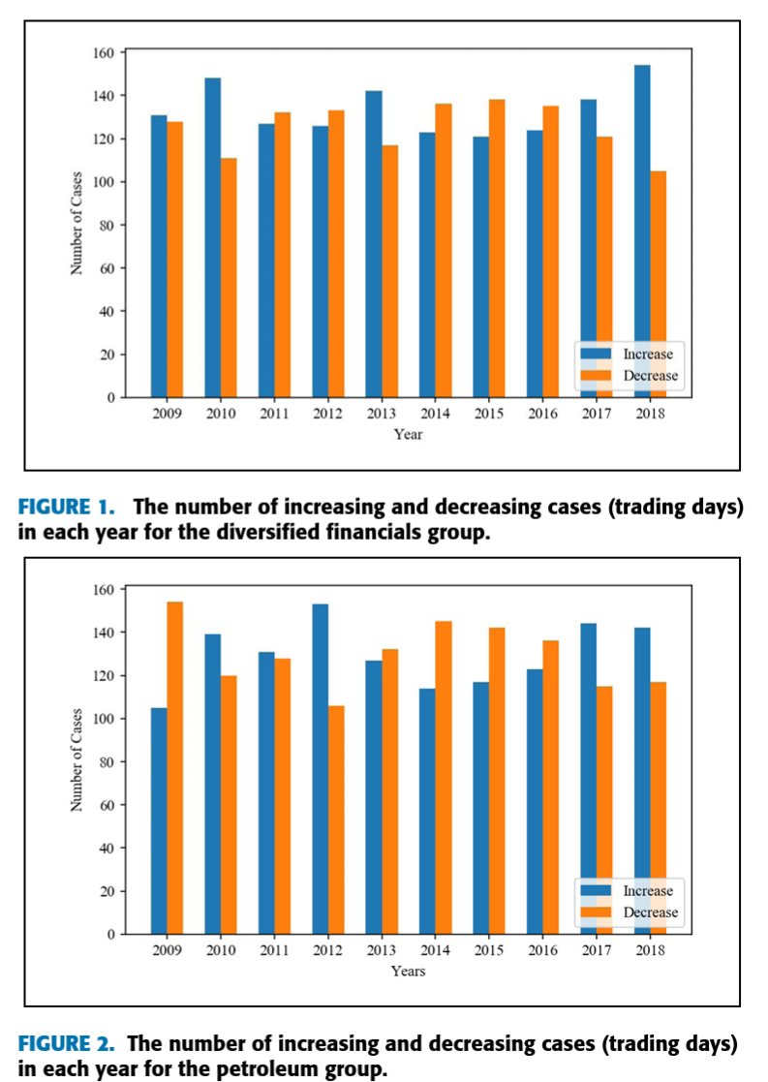

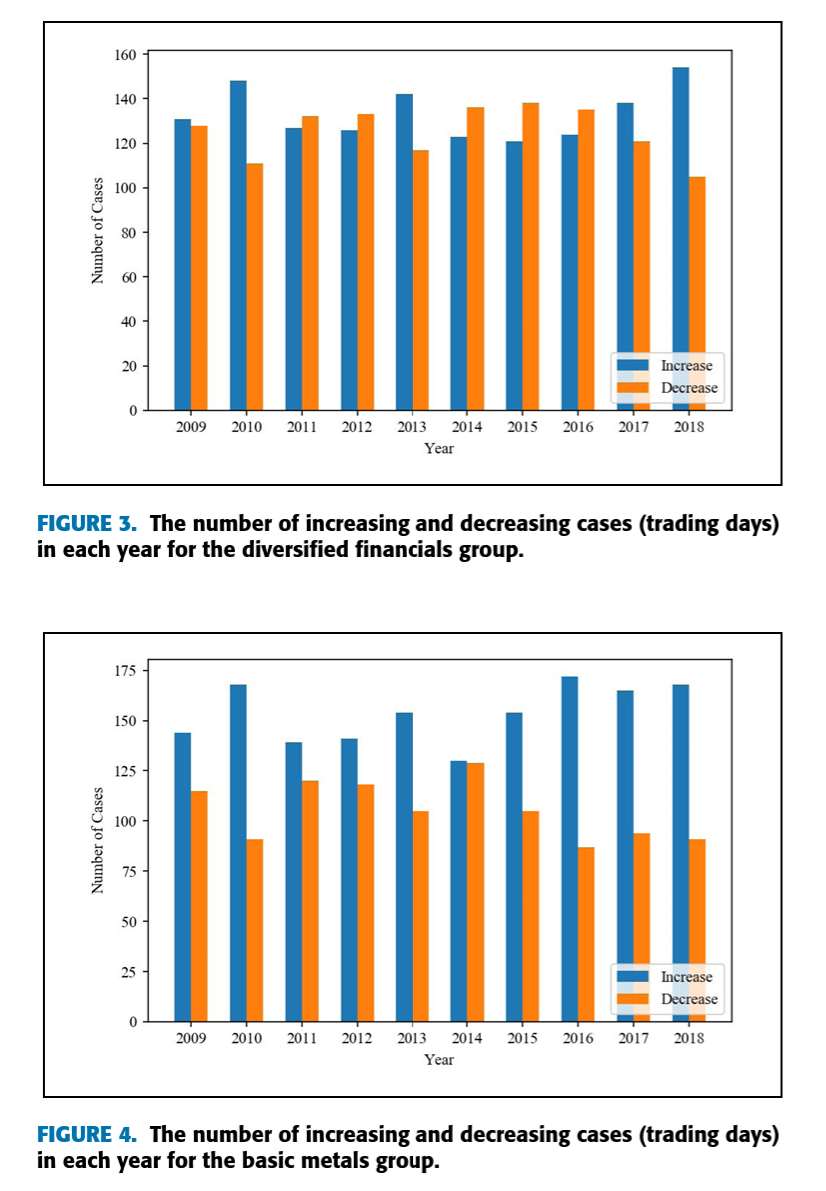

### Continuous Data

The continuous data approach involves calculating ten technical indicators (SMA, WMA, MOM, STCK, STCD, LWR, MACD, ADO, RSI, and CCI) based on historical stock price data (open, close, high, and low values). These indicators are normalized within the range (0, +1) to ensure comparability across different scales. The process of using continuous data for stock trend prediction is illustrated in Figure 5.

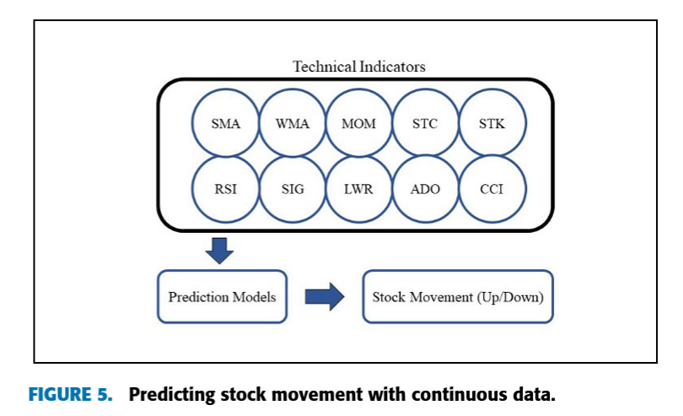

### Binary Data

In the binary data approach, continuous values of the indicators are converted to binary data (+1 for an upward trend, -1 for a downward trend) based on the nature of each indicator. The conversion process is shown in Figure 6. Specific rules for binary conversion of each indicator are outlined, such as for RSI, where values above 70 indicate a downward trend (-1), and values below 30 indicate an upward trend (+1).

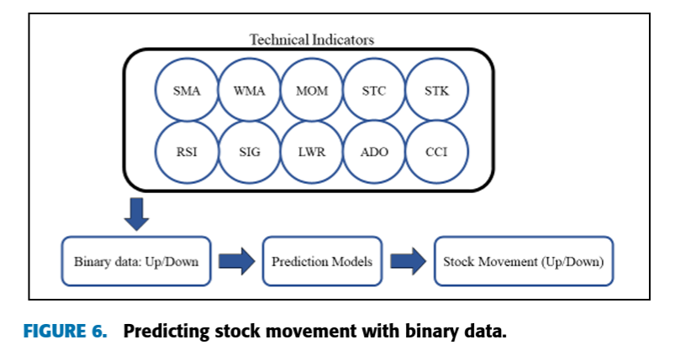

### Prediction Models

The study evaluates nine machine learning models (Decision Tree, Random Forest, AdaBoost, XGBoost, SVC, Naïve Bayes, KNN, Logistic Regression, and ANN) and two deep learning models (RNN and LSTM). Each model is adjusted for optimal performance using various hyperparameters. The technical indicators were used as input features, with stock price trends as the output target for all models.

* **Decision Tree**: Utilizes decision rules to predict stock trends. It is simple to interpret but prone to overfitting.
* **Random Forest**: An ensemble method that averages the results of multiple decision trees to improve prediction accuracy.
* **AdaBoost and XGBoost**: Both are boosting algorithms that sequentially improve model performance by focusing on harder-to-predict cases.
* **SVC**: A Support Vector Classifier, which identifies the decision boundary between two classes.
* **Naïve Bayes**: A probabilistic classifier based on Bayes' theorem, assuming feature independence.
* **KNN**: A non-parametric algorithm that classifies based on the majority vote of the k-nearest neighbors.
* **Logistic Regression**: Predicts categorical outcomes using a logistic function.
* **ANN, RNN, and LSTM**: Neural networks that learn complex relationships in data. LSTM, in particular, is useful for time-series data due to its ability to remember previous inputs

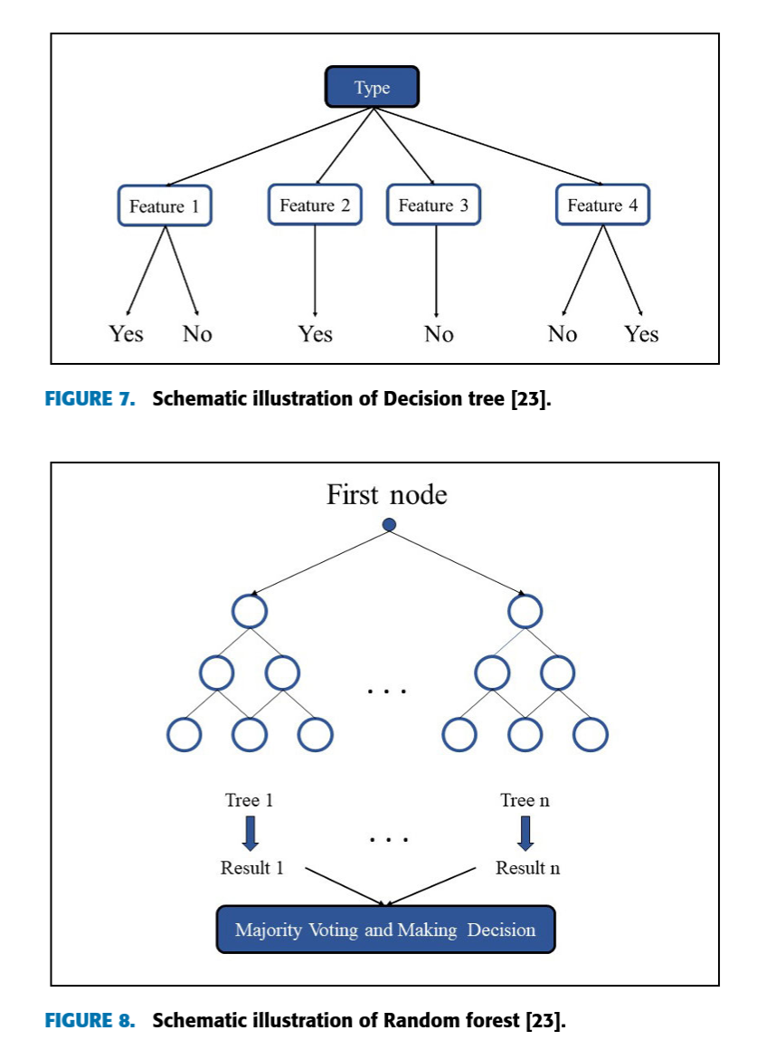

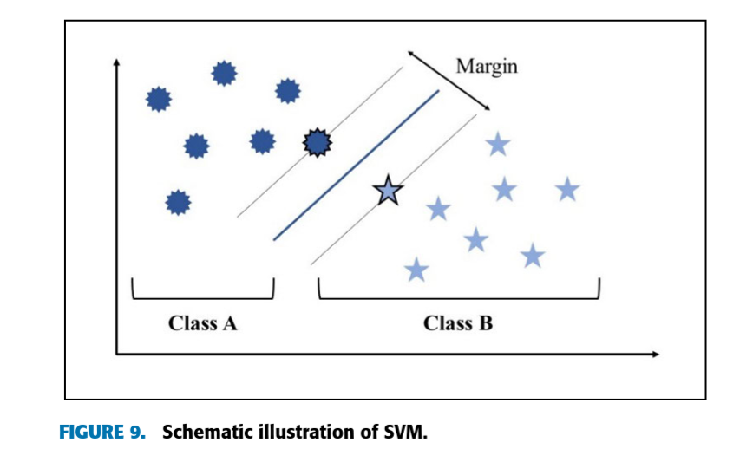

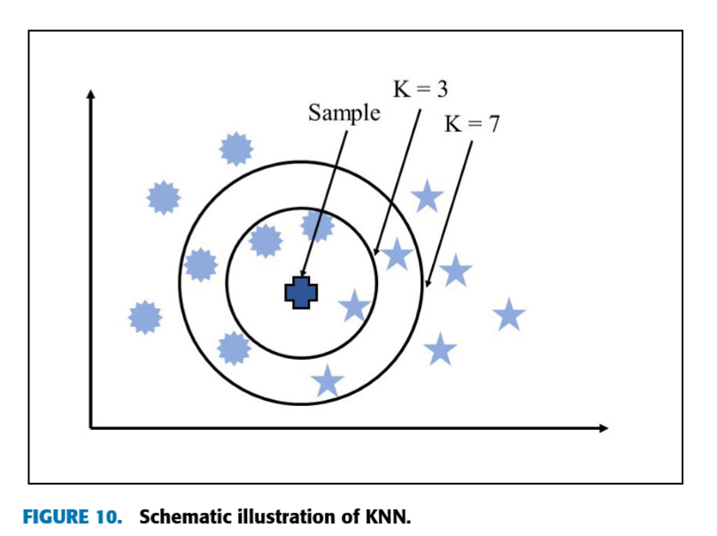

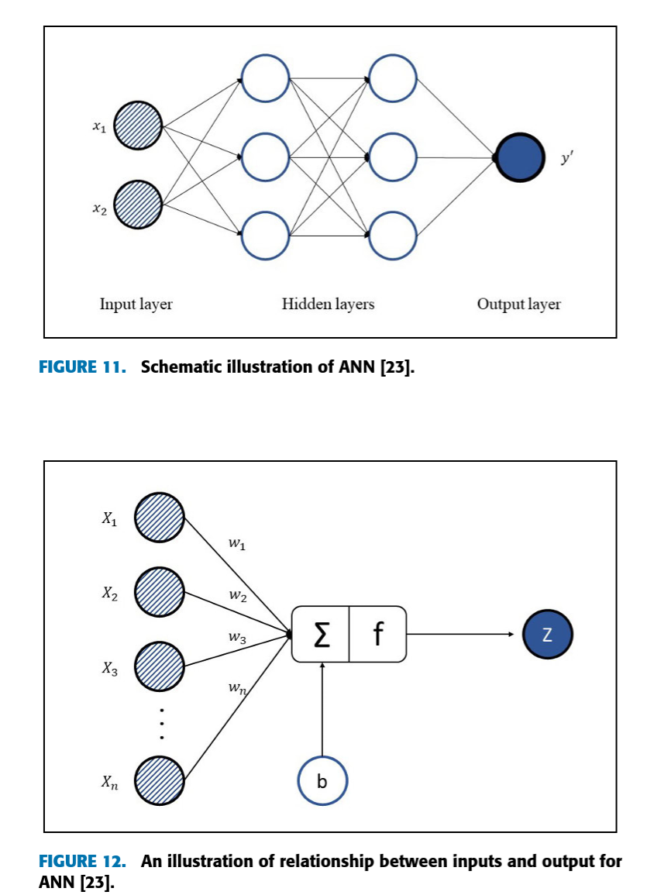

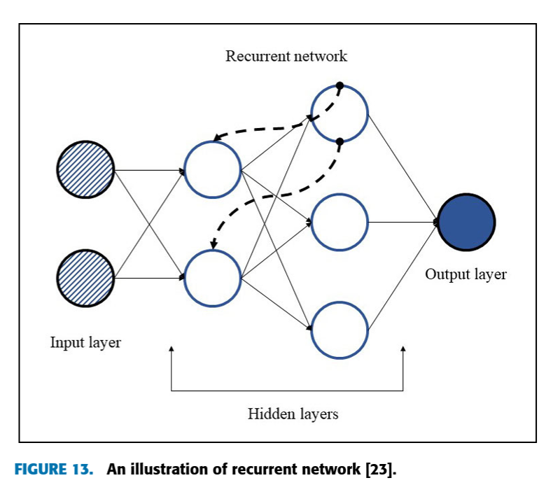

### Experimental Results

The models were evaluated using F1-Score, Accuracy, and ROC-AUC metrics. The dataset was split into training (70%) and test (30%) sets. Regularization techniques were used to prevent overfitting, and early stopping was employed during training. For RNN and LSTM models, a multi-day time series approach was used, while the other models were trained with ten technical indicators as input.

The results showed that:

* Deep learning models (RNN and LSTM) performed the best, particularly with continuous data, achieving an F1-Score of around 86%.
* Naïve Bayes and Decision Tree models were the least accurate, with F1-Scores of approximately 68%.
* In the binary data approach, all models showed improved performance, with F1-Scores increasing for all models. The gap between the top-performing models (RNN, LSTM) and others was reduced.
* RNN and LSTM continued to outperform other models with an F1-Score of approximately 90% when using binary data.

Figures 14 and 15 show the average F1-Scores across different models, with running time considerations factored in. The study concludes that while deep learning models excel in prediction accuracy, they require more computational resources. The binary data approach, though simpler, also yields significant improvements in prediction performance across all models.

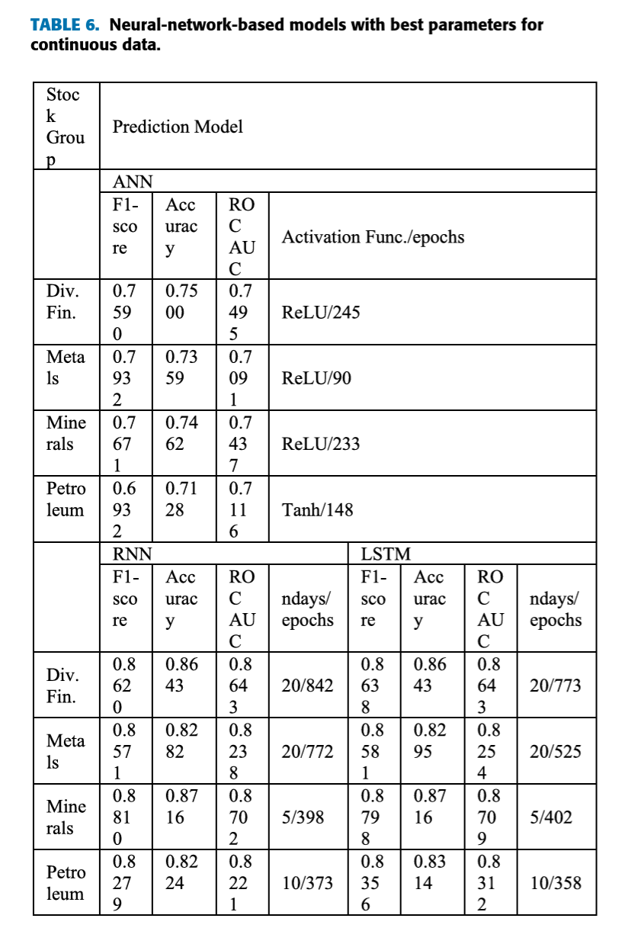

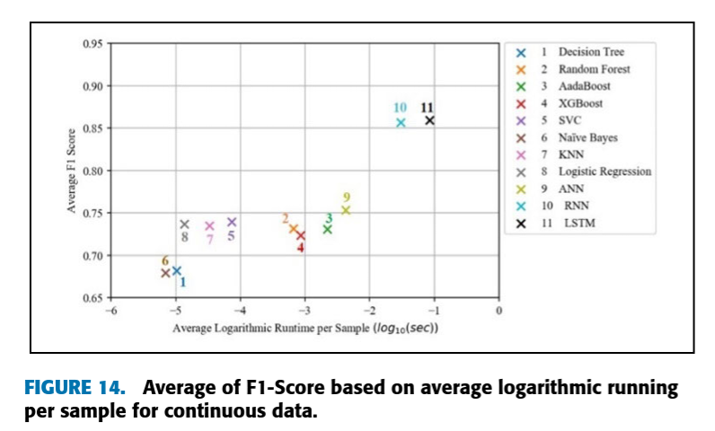

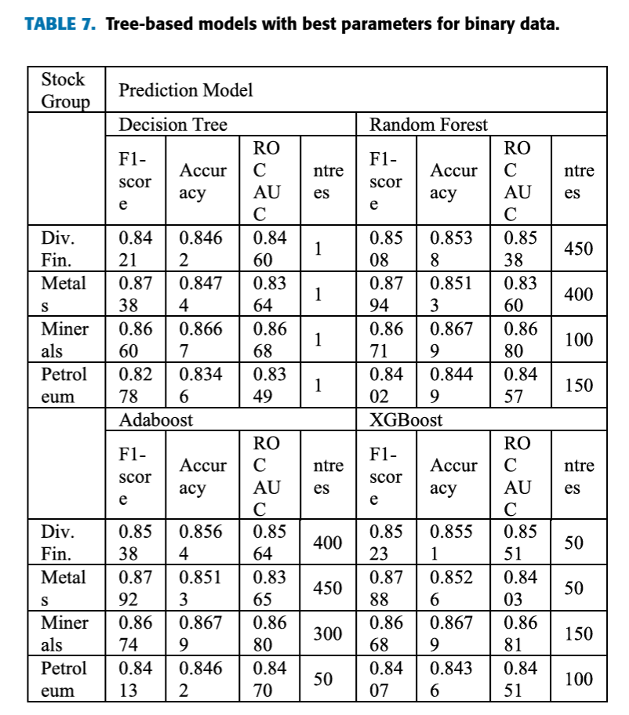

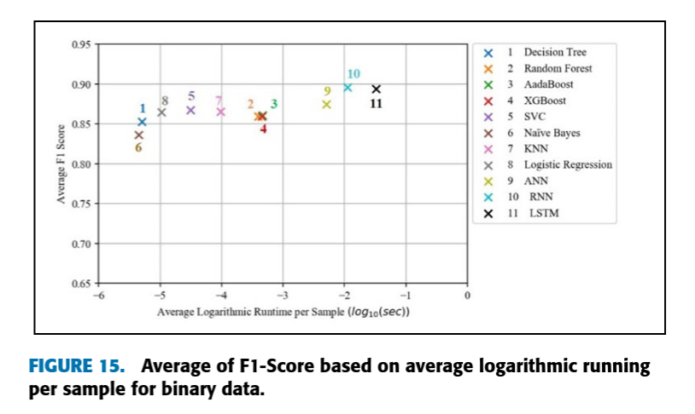

In summary, deep learning models (RNN and LSTM) demonstrate strong predictive capabilities in forecasting stock market movements, especially with continuous data. However, when computational efficiency is a concern, binary data can offer a faster, more streamlined alternative without sacrificing much in terms of accuracy.

**Conclusion**

The study aimed to predict stock market movements using machine learning and deep learning algorithms, focusing on four stock market groups from the Tehran Stock Exchange: diversified financials, petroleum, non-metallic minerals, and basic metals. The dataset comprised ten years of historical stock data with ten technical indicators as features. The research employed nine machine learning models, including Decision Tree, Random Forest, AdaBoost, XGBoost, Support Vector Classifier (SVC), Naive Bayes, K-Nearest Neighbors (KNN), Logistic Regression, and Artificial Neural Network (ANN), along with two deep learning models: Recurrent Neural Network (RNN) and Long Short-Term Memory (LSTM). Two approaches were utilized for inputting data into the models: continuous data, where technical indicators were used in their raw form, and binary data, where indicators were converted into binary values to represent positive trends as +1 and negative trends as -1. The models' performance was evaluated using three classification metrics: accuracy, F1-score, and ROC-AUC (Receiver Operating Characteristic – Area Under Curve). The findings revealed a significant improvement in performance when models utilized binary data instead of continuous data, enhancing their ability to capture stock market trends. Notably, deep learning algorithms, specifically RNN and LSTM, outperformed traditional machine learning models, demonstrating superior accuracy and trend prediction capabilities in both data scenarios. Ultimately, the study concluded that RNN and LSTM models are the most effective for predicting stock market trends when using binary technical indicators as input data, confirming that transforming continuous indicators into binary signals can significantly enhance prediction accuracy in financial forecasting.

**References and Citations**

1. CNN based Image Quality Classification - Neural Networks:

G. -H. Gwon, J. H. Lee, I. -H. Kim and H. -J. Jung, "CNN-Based Image Quality Classification Considering Quality Degradation in Bridge Inspection Using an Unmanned Aerial Vehicle," in IEEE Access, vol. 11, pp. 22096-22113, 2023, doi: 10.1109/ACCESS.2023.3238204.

keywords: {Inspection;Image quality;Autonomous aerial vehicles;Distortion;Degradation;Convolutional neural networks;Convolutional neural networks;image quality classification;bridge inspection;unmanned aerial vehicle;motion blur;underexposure;overexposure},

2. Customer Service Optimization - Fuzzy Logic:

Marín Díaz, G.; Carrasco González, R.A. Fuzzy Logic and Decision Making Applied to Customer Service Optimization. *Axioms* **2023**, *12*, 448. <https://doi.org/10.3390/axioms12050448>

3. Predicting Stock Market Trends - Machine Learning and Deep Learning:  
M. Nabipour, P. Nayyeri, H. Jabani, S. S. and A. Mosavi, "Predicting Stock Market Trends Using Machine Learning and Deep Learning Algorithms Via Continuous and Binary Data; a Comparative Analysis," in IEEE Access, vol. 8, pp. 150199-150212, 2020, doi: 10.1109/ACCESS.2020.3015966.

keywords: {Stock markets;Machine learning;Predictive models;Market research;Prediction algorithms;Support vector machines;Indexes;Stock market;trends prediction;classification;machine learning;deep learning},